## **Racoon 301: Boarding/Interiors/CQB**

opening exterior doors on hostile ships (railguns, cutting tools, lmgs)

being aware of fields of view/windows on the ship when EVAing.  
Memorizing ship layout for: mercury, carrack, hercules, starfarer, hammerhead, 600, 890, reclaimer.

Exercise: inside a ship, from a point (airlock) pick a random other point (“forward port turret seat”). Test they know the way. Test they know two ways there. Which is best for attack? WHich for defense? Which will the opponent choose?

Teach terminology of interior CQB:

* corner fed vs. center fed doors
* identifying heavy vs. weak room sides
* thinking about your easy corners vs. hard corners
* identifying kill zones

Example reference:  
<https://www.projectgecko.info/new-blog-1/2015/9/3/cqb-education-pa>

<https://www.projectgecko.info/new-blog-1/2015/9/8/cqb-education-part-6-rooms-anatomy-2-guest-article>

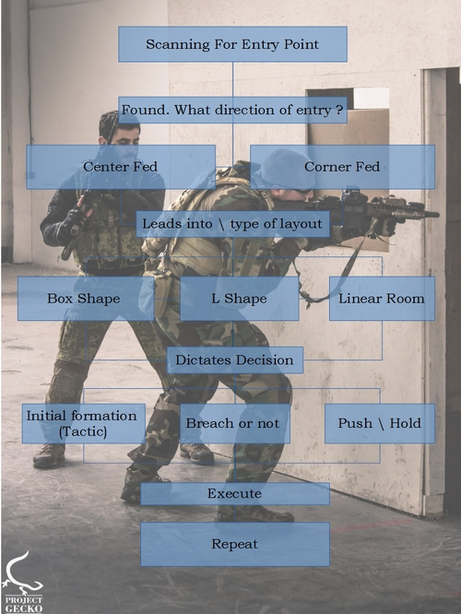  
Pie-ing angles  
Stacking  
Double your firepower by being high and low in a pair.

Practice communication  
Practice not flagging buddies

Practice moving through a new space (or a known space but from a different entry point) and calling out a terse but accurate description of that space to your team.

## **Racoon 302: Breaching/Defending**

Goal of the course is to improve the odds of breaching doors like Jumptown and external ship doors above a coin-flip by using correct weapon choices, positioning, psychology, and hard cover.  
  
Because we do not yet have good techniques in this space, majority of this class should be practicing movement, coordination, position and timing. Discussing where to put boxes. Discussing what the enemy will expect and where to be.  
  
Reference video: <https://www.youtube.com/watch?v=NFhA_A0rSAI>

## **Racoon 303: Sniper School**

In no particular order yet…

Key skills

* Understanding projectile falloff in gravity, zero-g, and crossing from one to the other.
* Variety of optics available – choosing the right one
* Zeroing zeroed optics for your target
* Minimizing your visibility
* Estimating ranges without optics
* Concealment vs. cover
* How cover varies at range in the star citizen engine

Types of optics

* Iron (none)
* Holographic/reflex
* Telescopic
* Fixed vs. simple ranging vs. autoranging
* Digital vs. optical

What is a Sniper?  
  
Rule #1 never be seen  
Rule #2 never miss  
Rule #3 always have a backup plan  
  
Common missions: Reconnaissance, Overwatch, Target Elimination  
  
No matter what you do, your job is to never be seen by the enemy. You should never be engaged by the enemy. They should not know from what direction you are attacking them. You may just be present and never fire, acting as a force multiplier for your team by your reconnaissance of the enemy position. Keep this in mind as we go through this course.  
  
Reconnaissance missions will require you to move away from your team to a valuable location where you can observe and communicate about the enemy’s position and actions. This will require knowledge of terrain, concealment, overland navigation, and precise communication.  
  
Overwatch missions place you watching over your team as they perform some action, watching for enemies who are unaware of your superior position. This will require knowledge of cover, marksmanship, and geography.  
  
Target elimination missions are similar to overwatch, but without your team on the field. Capturing bounties, guarding Jump Town doors, protecting bunker entrances from outside are all examples. This mission will require knowledge of terrain, concealment, cover, navigation, marksmanship, and tremendous patience as you wait for that one shot.  
  
We’ll cover all this tonight.  
  
Weapons  
  
Explain the different “sniper” weapons available in the game and their pros and cons. Discuss alpha damage, damage falloff curves, damage type, potential AoE, special fire modes, noise, magazine size, shot visibility in day and night. Discuss the mass of the entire system (weapon+optic+mags) and how that affects overland travel.  
  
- P6-LR  
- Arrowhead  
- Scalpel  
- Atzkav  
  
Briefly discuss pros/cons of various secondary weapon choices. Let every student hold and test fire every rifle. Ensure you brought enough ammo in a box.  
  
Ranging  
  
Exercise: estimating ranges, then measuring ranges. Training site should have a variety of objects to test – rocks, trees, ships, assistants – from 50m to 1200m.

Exercise: zeroing optics by estimate and by direct measurement. Discuss using objects with well-known sizes as references to calibrate your optics (doors, vehicles, standard buildings, even rocks, etc.) Estimate, then test with optics. Repeat this many times.

Exercise: understanding projectile falloff. Estimate, then measure projectile falloff in a variety of gravity conditions. Use 1G site, low-G site, and zero-G site. Recommend sites: hurston, arial, and arial comm array.

Exercise: marksmanship at range. Assistant places a number of targets (picos? explosive canisters from bunkers, etc.) at ranges 200-1200m from the class and the class practices marksmanship using ranging and falloff from earlier in the course. Snipers don’t often get a second shot. Gotta make that first one count.

Navigation

Sniping often entails taking up a position alone, ahead of your party, or at a different, advantageous angle. This can require overland navigation.  
  
Navigation methodology varies by orbital body, weather, and time of day.

* stars/gas giants
* stanton
* Local geological phenomenon
* Items you bring with you (mission boxes, ships)
* bearings from friendly ships

Standard orienteering practices: choose two objects aligned along your direction of travel. As you travel, keep them aligned. As you reach the nearer object, choose another, past the second object. This can give you rough, linear overland travel without equipment or other environmental references.  
  
When moving overland, optics can be used to measure distances to positions ahead or to geographic features. Advanced students may use these measurements plus aerial maps to triangulate very specific positions or even give navigation instructions to teammates. But that’s for another class.

Exercise: from the starting point, gives pairs of students a predetermined but unmarked destination approximately two kilometers away. Point them in the correct direction from the starting point and let them loose. See how close they get to the target point (both in distance and angle). Discuss. Repeat with a different target. Instructors will need a decent list of known positions (cactus, rocks, hilltops, etc.) and the bearings and distances between them.  
  
Final exercise: a target (assistant) is nearby. In pairs, the students must use travel directions to cover ground, take up a position without being seen, and kill the target before he knows he’s in danger. A missed shot will send him running to cover.  
  
Debrief and decamp back to station.  
  
Final note: practice practice practice practice practice. Nothing will take the place of practice when you have just one shot.  
  
—  
  
Extra topics we should work in:

* dealing with suspicious opponents who are moving towards you – how to have multiple escape routes
* moving between shots if necessary
* deciding whether you need a buddy/spotter (some weapons that kick you out of the optic), maybe you need two shots to guarantee the hit, maybe you need other equipment, like heavy weapons
* food/drink during long stays in hostile environments
* Managing heart rate during long marches (jumping in low-g, lighter armor, at what heart rate to slow down, etc.)
* Distinguishing friends from foes in overwatch – know your team’s armor and gear
* Weather effects on armor
* Weather effects not working on weapons and backpacks